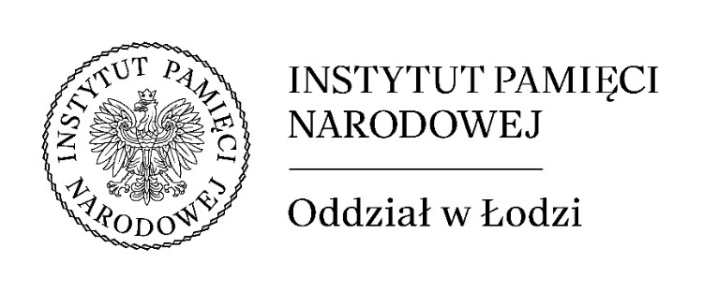

REGISTRATION FOR PARTICIPATION IN THE INTERNATIONAL SCIENTIFIC CONFERENCE
“So many lives lost. Civilians and the Soviet totalitarian system in the 20th century”

The conference will take place on September 24–25, 2026, in Łódź.
Applications by May 31, 2026.

Full name, degree/academic title: ...................................................................................................
Affiliation:..................................................................................................................................................
....................................................................................................................................................................
Correspondence address: .........................................................................................................................
..................................................................................................................................................................
Tel./fax ................................................................ e-mail .........................................................................

Title of presentation
........................................................................................................................................................................................................................................................................................................................................

Abstract (min. 1000 characters)
…………………………………………………………………………………………………………………………………………………………………………………………………………………………………………………………………………………………………………………………………………………………………………………………………………………………………………………………………………………………………………………………………………………………………………………………………………………………………………………………………………………………………………………………………………………………………………………………………………………………………………………………………………………………………………………………………………………………………………………………………………………………………………………………………………………………………………………………………………………………………………………………………………………………………………………………………………………………………………………………………………………………………………………………………………………………………………………………………………………………………………………………………………………………………………………………
Biographical note ………………………………………………………………………………………………………………………………………………………………………………………………………………………………………………………………………………………………………………………………………………………………………………………………………………………………………………………………………………………………………………………………………………………………………………………………………………………………………………………………………………

……………………………………………………….
(date, signature)

I consent to the free use of my image in accordance with Article 81(1) of the Act on Copyright and Related Rights, registered in connection with my participation in the international scientific conference entitled ‘So Many Lives Lost. Civilians and the Soviet Totalitarian System in the 20th Century’ for the purpose of promoting the educational and research activities of the Institute of National Remembrance by publishing reports on the conference on websites and official social media profiles, as well as in the Organiser's publications and multimedia materials.

 
YES NO

I consent to the inclusion and processing of my personal data in the address database of the Branch Office for Historical Research of the Institute of National Remembrance – Commission for the Prosecution of Crimes against the Polish Nation in Łódź, with the possibility of correcting and supplementing it, in all educational and research activities conducted by the IPN.

 
YES NO

Information clause regarding the processing of personal data in connection with your participation in the scientific conference entitled: ‘So many lives lost. Civilians and the Soviet totalitarian system in the 20th century’ organised by the Institute of National Remembrance – Commission for the Prosecution of Crimes against the Polish Nation, Łódź Branch
Your personal data will be processed for the following purposes:
- participation in the event: scientific conference entitled ‘So many lives lost. Civilians and the Soviet totalitarian system in the 20th century’ organised by the Institute of National Remembrance – Commission for the Prosecution of Crimes against the Polish Nation, Łódź Branch;
- publication of images in event reports posted on websites and official social media profiles, as well as in the organiser's publications and multimedia materials;
- the inclusion and processing of personal data in the address database of the Branch Office for Historical Research of the Institute of National Remembrance – Commission for the Prosecution of Crimes against the Polish Nation, Łódź Branch, with the possibility of correcting and supplementing such data, in all educational and research activities conducted by the IPN.
The legal basis for data processing is Article 6(1)(a) (your consent) and Article 6(1)(e) (processing is necessary for the performance of a task carried out in the public interest or in the exercise of official authority - Article 53(4) and (5) of the Act on the Institute of National Remembrance - Commission for the Prosecution of Crimes against the Polish Nation), Regulation (EU) 2016/679 of the European Parliament and of the Council of 27 April 2016 on the protection of natural persons with regard to the processing of personal data and on the free movement of such data, and repealing Directive 95/46/EC, hereinafter referred to as the GDPR.
The administrator of your personal data is the President of the Institute of National Remembrance – Commission for the Prosecution of Crimes against the Polish Nation, with its registered office in Warsaw, address: ul. Janusza Kurtyki 1, 02-676 Warszawa. The personal data controller ensures appropriate technological, physical, administrative and procedural data protection measures to protect and ensure the confidentiality, accuracy and availability of the personal data being processed, as well as protection against unauthorised use or unauthorised access to personal data and protection against personal data security breaches.
Contact details of the Data Protection Officer at the Institute of National Remembrance – Centre for the Documentation of the Crimes against the Polish Nation: inspektorochronydanych@ipn.gov.pl, postal address: ul. Janusza Kurtyki 1, 02-676 Warszawa.
The recipients of your personal data may be entities authorised by law and entities authorised by the Controller.
Your personal data will be processed until the end of the organised event and the end of the publication of reports from the event on websites and official social media profiles, as well as in the organiser's publications and multimedia materials, and until your consent is withdrawn, and then stored by the Institute of National Remembrance – Commission for the Prosecution of Crimes against the Polish Nation, Łódź Branch, in accordance with the deadlines specified in the IPN's Subject File List, issued pursuant to Article 6(2) of the Act of 14 July 1983 on national archival resources and archives.
You have the right to access your personal data and the right to rectify, delete or restrict its processing, the right to object to its processing, and the right to transfer your data.
You have the right to lodge a complaint with the President of the Personal Data Protection Office if you believe that the processing of personal data violates the provisions of the GDPR.
You have the right to withdraw your consent to the processing of personal data at any time. Withdrawal of consent shall not affect the lawfulness of processing based on your consent before its withdrawal.

