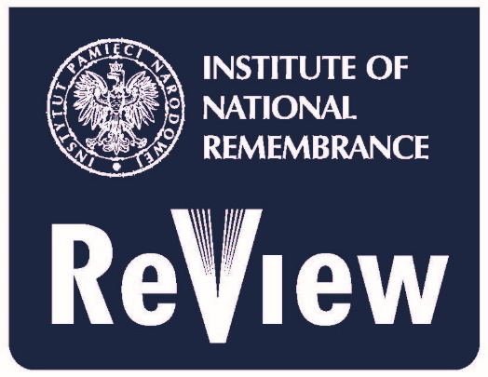

Institute of National Remembrance Review
Institute of National Remembrance
– Commission for the Prosecution of the Crimes against the Polish Nation
Wołoska 7, 02-675 Warsaw, Poland
email: inrr@ipn.gov.pl

Call for papers: „Great Patriotic War”.

CfP symbol: A/GPW
The Editorial Board of the Institute of National Remembrance Review calls for submissions of the papers concerning the so-called Great Patriotic War, its contexts and consequences.
We assume, that the real circumstances and contexts of Soviet contribution to the outbreak of the Second World War, Soviet war plans and wartime policies, and the consequences of the war for the nations affected, should be reminded and emphasised. The aim of such a collection would be an objective, unbiased and respecting the victims of the war review of the state of research and findings in the field, and an analysis of the propaganda and myth-creating dimensions of the ‘Great Patriotic War’.
We see the general division into three groups of problems to be developed:

1. Soviet Union and the beginnings of Second World War (1938-1941)
- The Soviet position towards Munich Agreement and subsequent developments in Central Europe until the outbreak of war;
- The Ribbentrop-Molotov Pact, its contexts and results;
- The Soviet aggression against Poland and Finland;
- The Soviet annexations of Baltic countries and Bessarabia;
- The Soviet rule in conquered and annexed territories;
- The German-Soviet alliance, its political, military, and economic aspects;

2. The reality of the German-Soviet war (1941-1945) and its aftermath
- The Soviet Army in fight: command, strategies, tactics;
- The NKVD troops as a factor of military operations;
- The treatment of the POWs by Soviet authorities;
- The Soviet POWs in German, Finnish, Hungarian, Romanian and Italian captivity;
- The Soviet military losses;
- The human war losses: sacrifice in a popular and authorities’ approach in Soviet Union;
- The Soviet economy in war effort;
- The Soviet concentration camps system and its participation in war effort;
- The role of the Lend-Lease program in the Soviet war effort;
- The reaction of the population of Soviet-ruled territories to the German entry;
- The German policy in occupied Soviet territories, its differences and changes;
- The Soviet military operations and local resistance/insurgency activities;
- The Soviet position towards Polish and Czechoslovak governments in exile;
- The Soviet position towards Central European federation plans;
- The Tehran, Crimea and Potsdam conferences: Soviet war plans and their fulfilment;
- The “liberation” and patterns of establishment of Soviet rule or Soviet-dependent dictatorships in Central and Eastern Europe 1944-1948;
- The Soviet Union and attempts of independence restitution of the German-occupied countries, relatively of the breaking out of alliance with Germany;
- The Soviet union and territorial integrity of the Centrale and Eastern European countries;
- The liberation of the German concentration and POW camps: military and political contexts;
- The Soviet pacification of the captured territories 1944-1947: counterinsurgency operations, “filtration camps”, deportations;
- The Soviet Union position towards its satellites in Paris Treaties negotiations (1946–1947);
- The US Stimson/Welles Doctrine and Soviet conquests;
- The war reparations for the Soviet Bloc countries: formal solutions, contexts, and real outcome;

3. „Great Patriotic War” in propaganda and narratives:
- The Soviet domestic war propaganda 1941-1945;
- The Soviet war effort in Allied war propaganda;
- The “Great Patriotic War” in postwar propaganda and narratives in Soviet Union and Soviet Bloc countries;
- The Myth of the Soviet “liberation”;
- The “Great Patriotic War” in contemporary state narratives in Russia and Belarus;
- The “Great Patriotic War” and the World War II in the contemporary historical narrations in Ukraine.

The eligibility of eventual proposals of the papers reaching beyond the mentioned themes (however considering the general matters of the Great Patriotic War) will be considered by the INRR Editorial Board.

