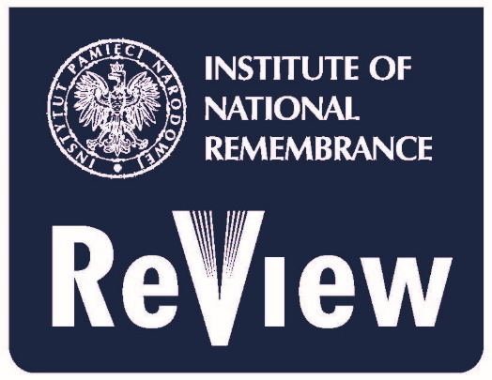

Institute of National Remembrance Review
Institute of National Remembrance
– Commission for the Prosecution of the Crimes against the Polish Nation
Wołoska 7, 02-675 Warsaw, Poland
email: inrr@ipn.gov.pl

Call for papers: „ New Central Europe. 1917-1922 & 1988-1992. The nations of Central and Eastern Europe facing the fall of empires.”
CfP symbol: B/NCE
The Editorial Board of the Institute of National Remembrance Review calls for submissions of the papers concerning the emergence and re-emergence of the independent states in Central and Eastern Europe in the two parallel turning points of history. The authors are encouraged to submit papers concerning two periods of Central and Eastern European history in the 20th century:
1. The emergence of independent Central and Eastern European countries as a consequence of the fall of the Austrian-Hungarian Empire, the Revolution in Russia and the German defeat in the First World War;
2. The political transition in Central and Eastern Europe after the fall of Soviet dominance, disintegration of the Soviet Union, Yugoslavia and Czechoslovakia.
The themes of the papers should touch upon i.a.:
- The matters of political processes resulting in restitution/establishment of independent Finnish, Estonian, Latvian, Lithuanian, Polish, Czechoslovak, Yugoslavian states in 1918;
- The Ukrainian Revolution; the Bolshevik Revolution; the Hungarian Revolution;
- The failed Belarusian Republic;

- The economic, political and military contexts of the fall of Soviet dominance in Central and Eastern Europe;

- The political transition in the countries of the former Soviet bloc;

- The processes and patterns of the disintegration of the Soviet Union; the restitution of the independent Baltic countries.

